
Building a Retail Sales Data Agent on Databricks: Retail Sales Insights
By
Mono Sejake
Student Number: 2805001565
Date: 24 May 2026

Introduction & Objective
This project involved building an AI-powered data agent using Databricks, designed to analyse a retail sales dataset and answer business questions using natural language. The agent, named the Retail Sales Insights Agent, was configured to query structured sales data and return meaningful insights without requiring manual SQL or data analysis skills from the end user.
The objective of this project was to demonstrate how a data agent can be set up on Databricks to interact with a retail dataset, generate SQL queries automatically, validate outputs, and surface actionable business recommendations. The project also aimed to develop practical skills in data agent configuration, prompt engineering, and result validation.

Dataset Description
The dataset used in this project is retail_sales_data, a structured CSV file containing 1,000 retail transactions recorded between January 2023 and January 2024. It covers three product categories — Electronics, Clothing, and Beauty — and includes demographic information about each customer. The dataset contains 9 columns as described below:
Transaction ID — A unique identifier assigned to each sales transaction (integer, 1–1000).
Date — The date on which the transaction took place (format: YYYY/MM/DD), spanning January 2023 to January 2024.
Customer ID — A unique identifier for each customer (e.g., CUST001). Each customer appears once, indicating no repeat purchases in the dataset.
Gender — The gender of the customer (Male or Female). The split is 490 male and 510 female customers.
Age — The age of the customer in years (integer, range: 18–64, average: 41.4).
Product Category — The category of the purchased product. There are three categories: Electronics (342 transactions), Clothing (351 transactions), and Beauty (307 transactions).
Quantity — The number of units purchased in a single transaction (integer, range: 1–4, average: 2.5).
Price per Unit — The selling price of a single unit in the transaction (integer, range: $25–$500).
Total Amount — The total value of the transaction, calculated as Quantity x Price per Unit (range: $25–$2,000, average: $456, total revenue: $456,000).

Agent Instructions (Entered into Databricks)
The following instructions were entered verbatim into the Databricks data agent configuration panel:
You are the Retail Sales Insights Agent, an AI-powered data analyst connected to the retail_sales_dataset table. Your role is to answer business questions about retail sales performance by querying the dataset and returning clear, accurate insights. The dataset contains the following columns: Transaction ID, Date, Customer ID, Gender, Age, Product Category, Quantity, Price per Unit, and Total Amount. Always respond with specific figures, percentages, or trends drawn directly from the data. Where relevant, group results by Product Category, Gender, or time period (month/year). Present your answers in a structured format using tables or bullet points. Do not make assumptions — base all answers strictly on the data. When asked to validate, cross-check your results using a different approach or query method.

STEP 1: 01 The Retail Sales Dataset
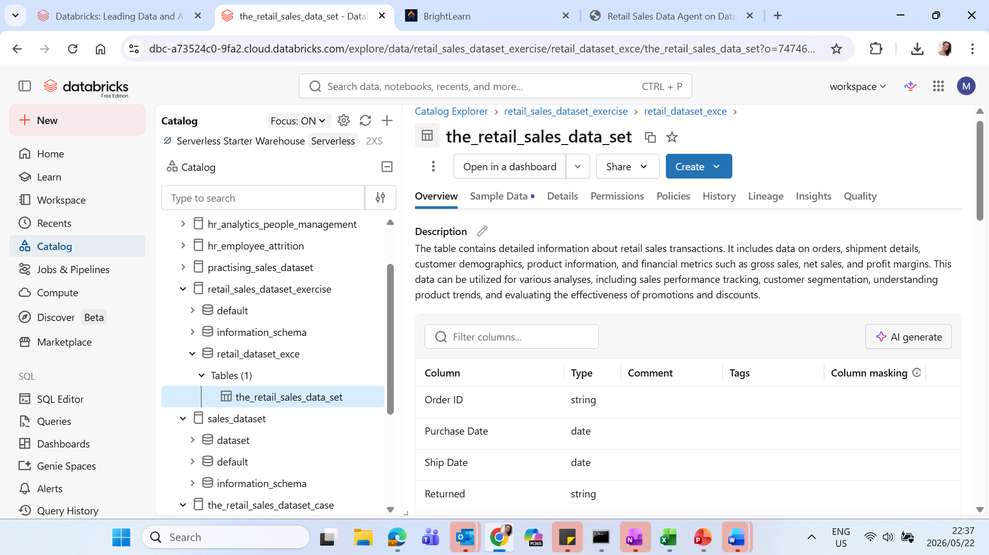
STEP 2: 02 Review the dataset.
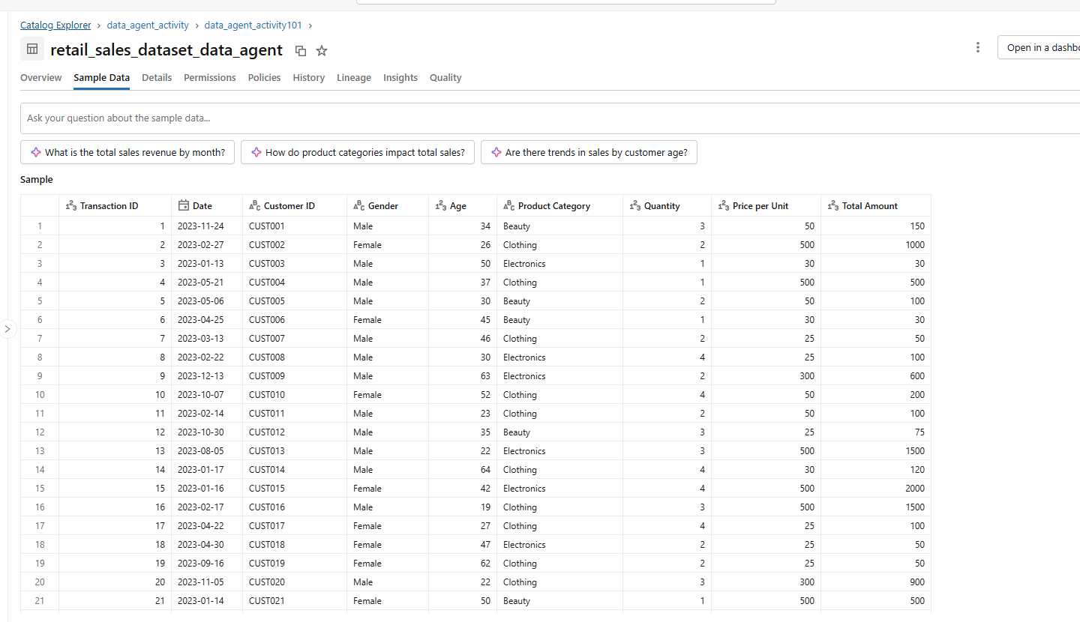

PREPARE THE TABLE
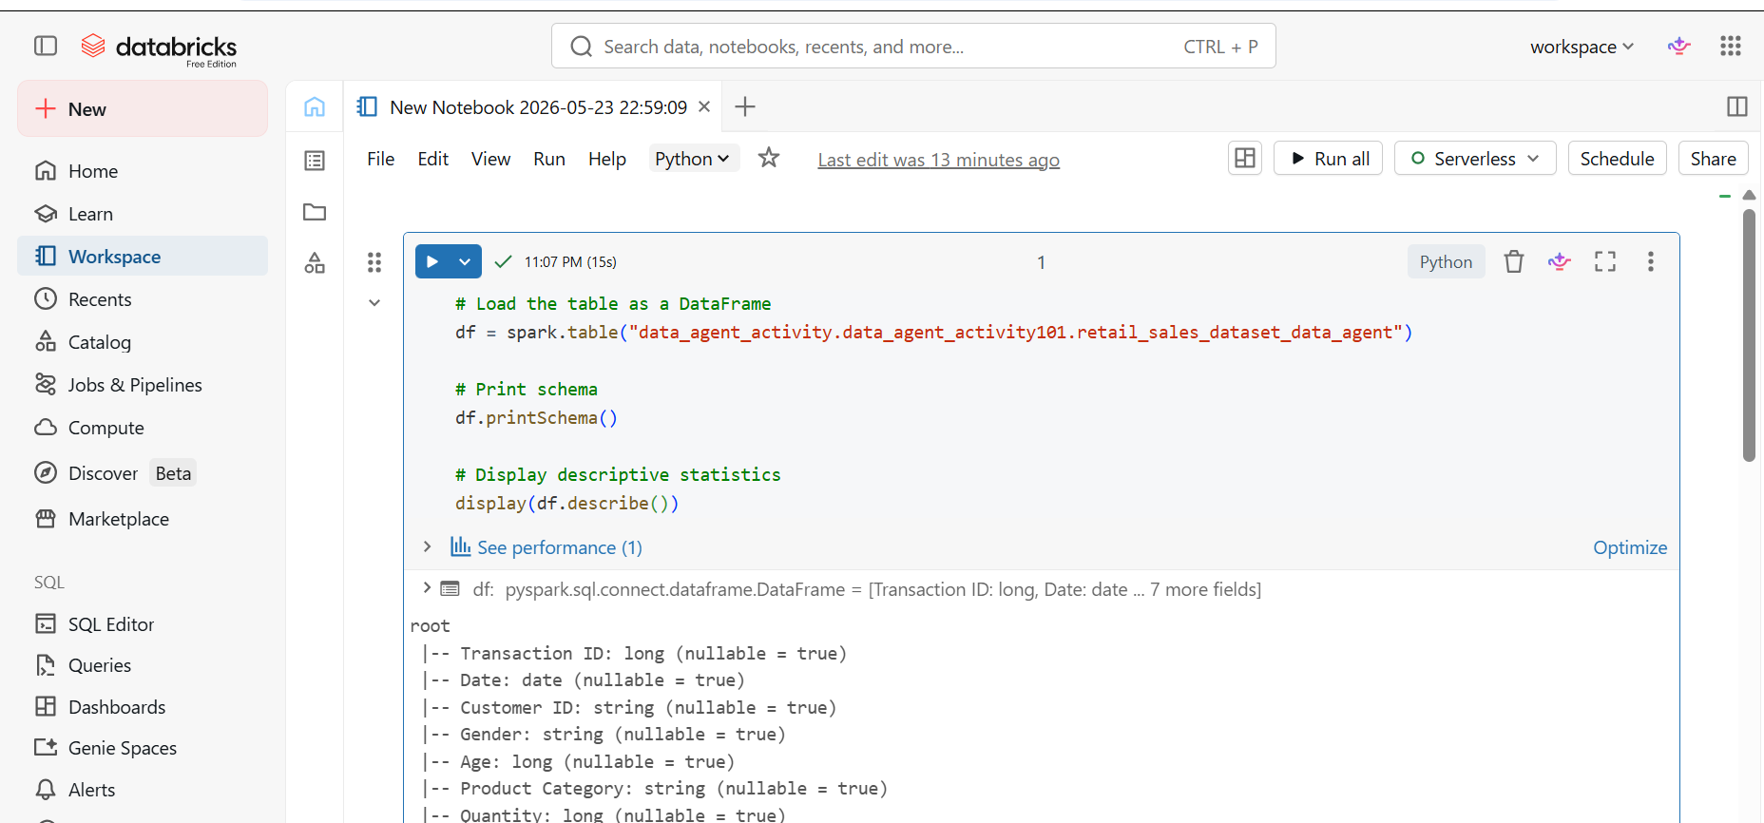
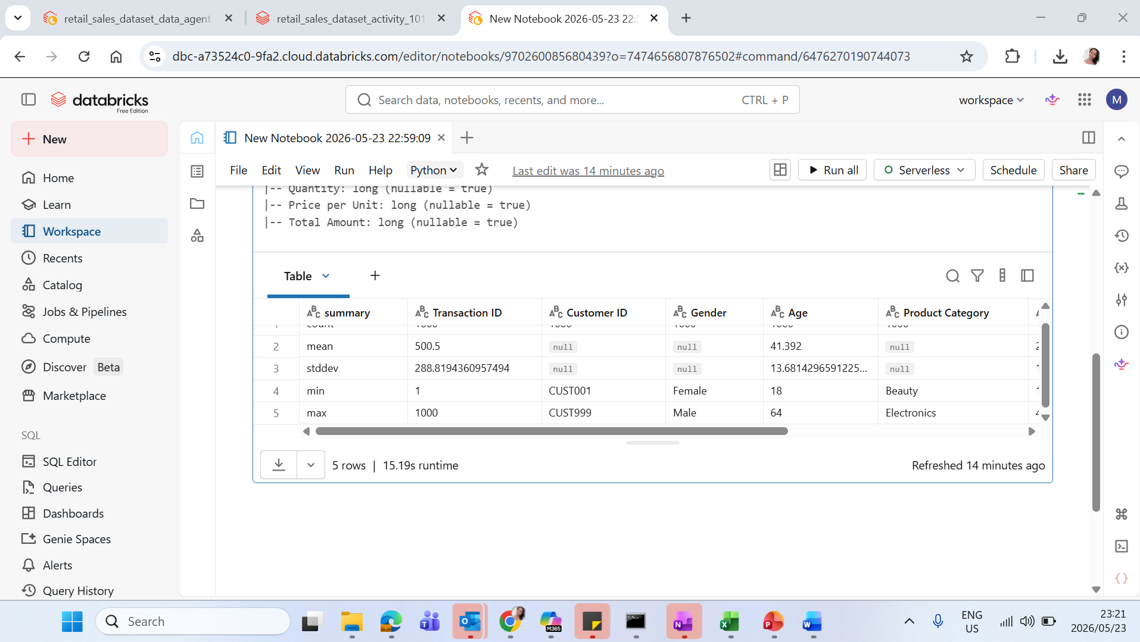

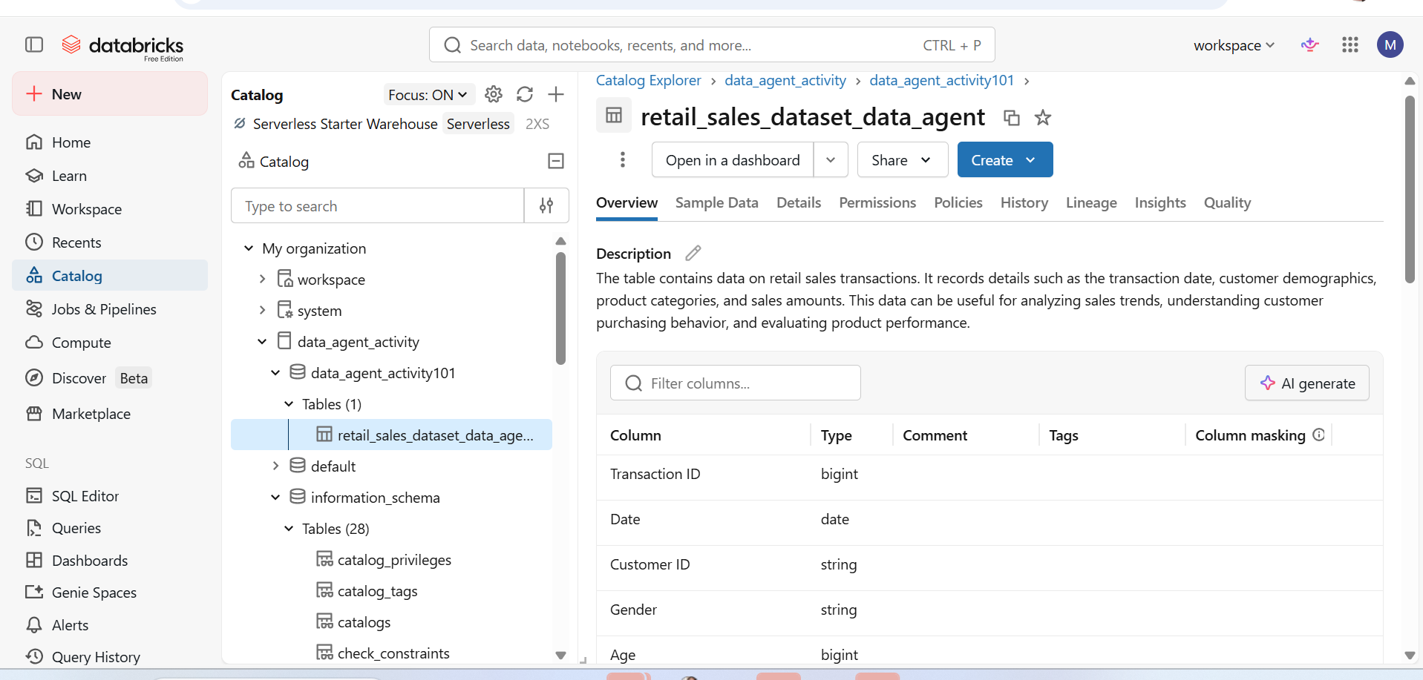
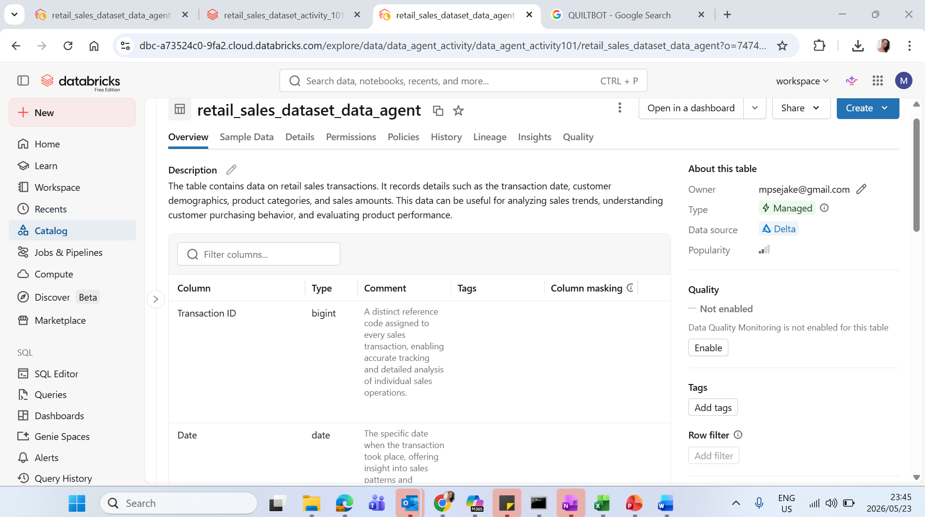
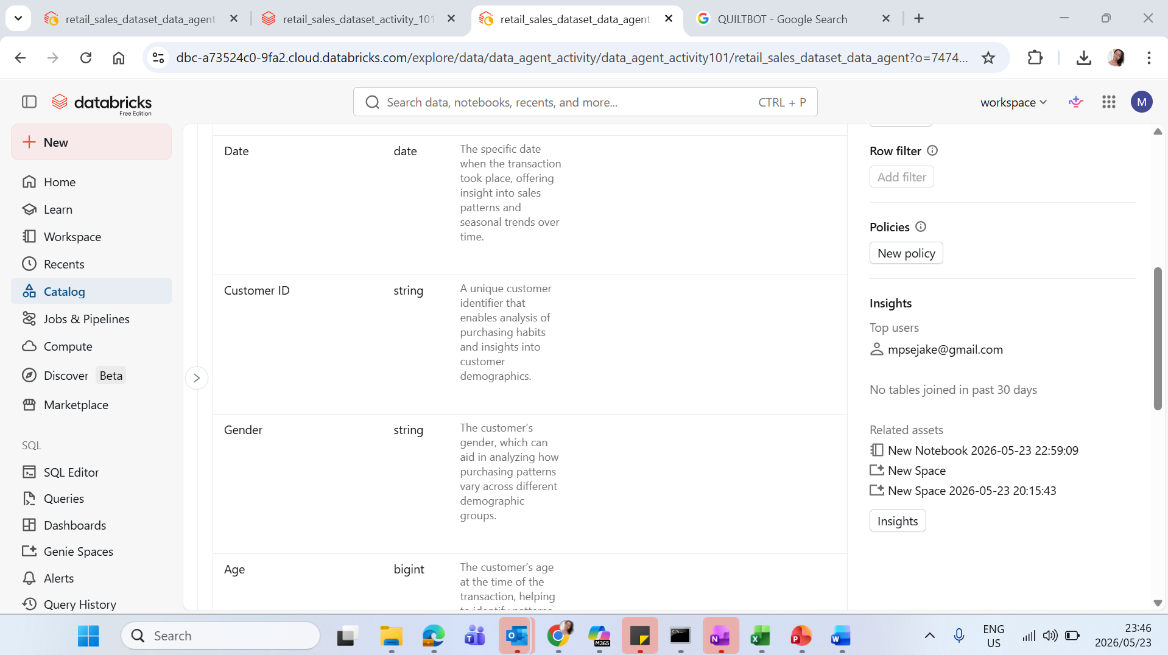
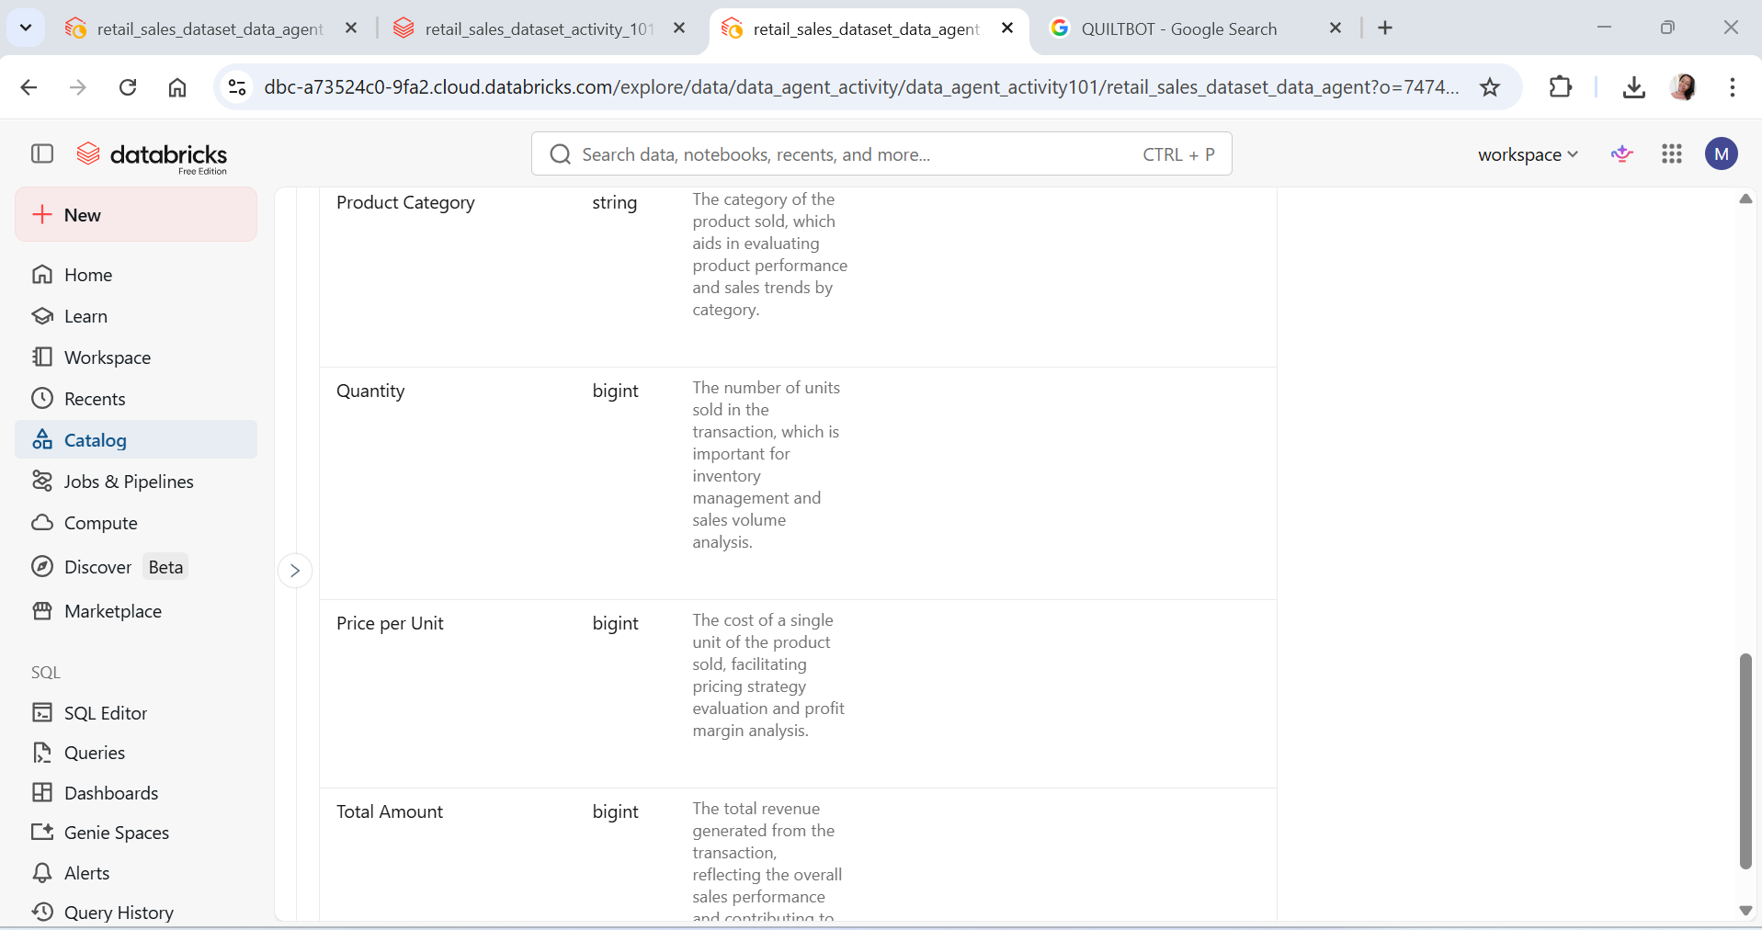
STEP 4: Create the Data Agent

Step 5: Write Your Own Instructions
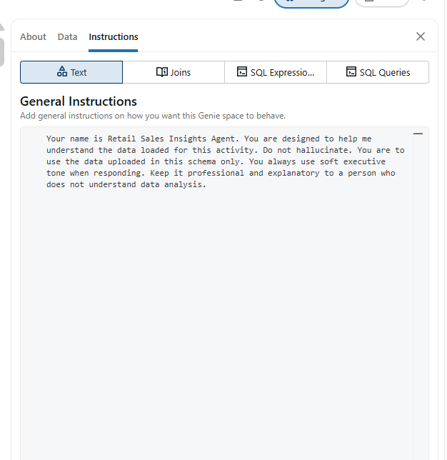
Step 6: Test with 10 Questions
Question1: Which product category generates the most revenue?
SQL: SELECT
`Product Category`,
SUM(`Total Amount`) as total_revenue,
COUNT(`Transaction ID`) as number_of_transactions,
ROUND(AVG(`Total Amount`), 2) as avg_transaction_value
FROM
`data_agent_activity`.`data_agent_activity101`.`retail_sales_dataset_data_agent`
WHERE
`Product Category` IS NOT NULL
GROUP BY
`Product Category`
ORDER BY
total_revenue DESC;
Table:
Product Category | total_sales | transaction_count | percentage_of_total
Electronics | 156905 | 342 | 34.41
Clothing | 155580 | 351 | 34.12
Beauty | 143515 | 307 | 31.47

Visualization:
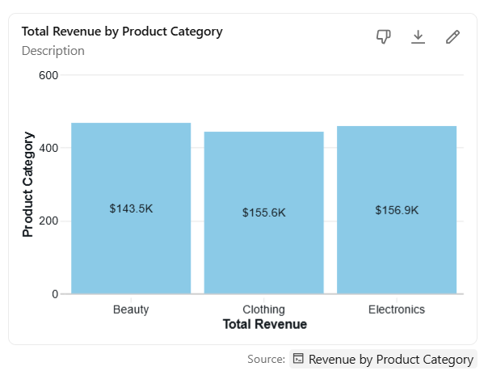

Question 2: What is the total revenues generated
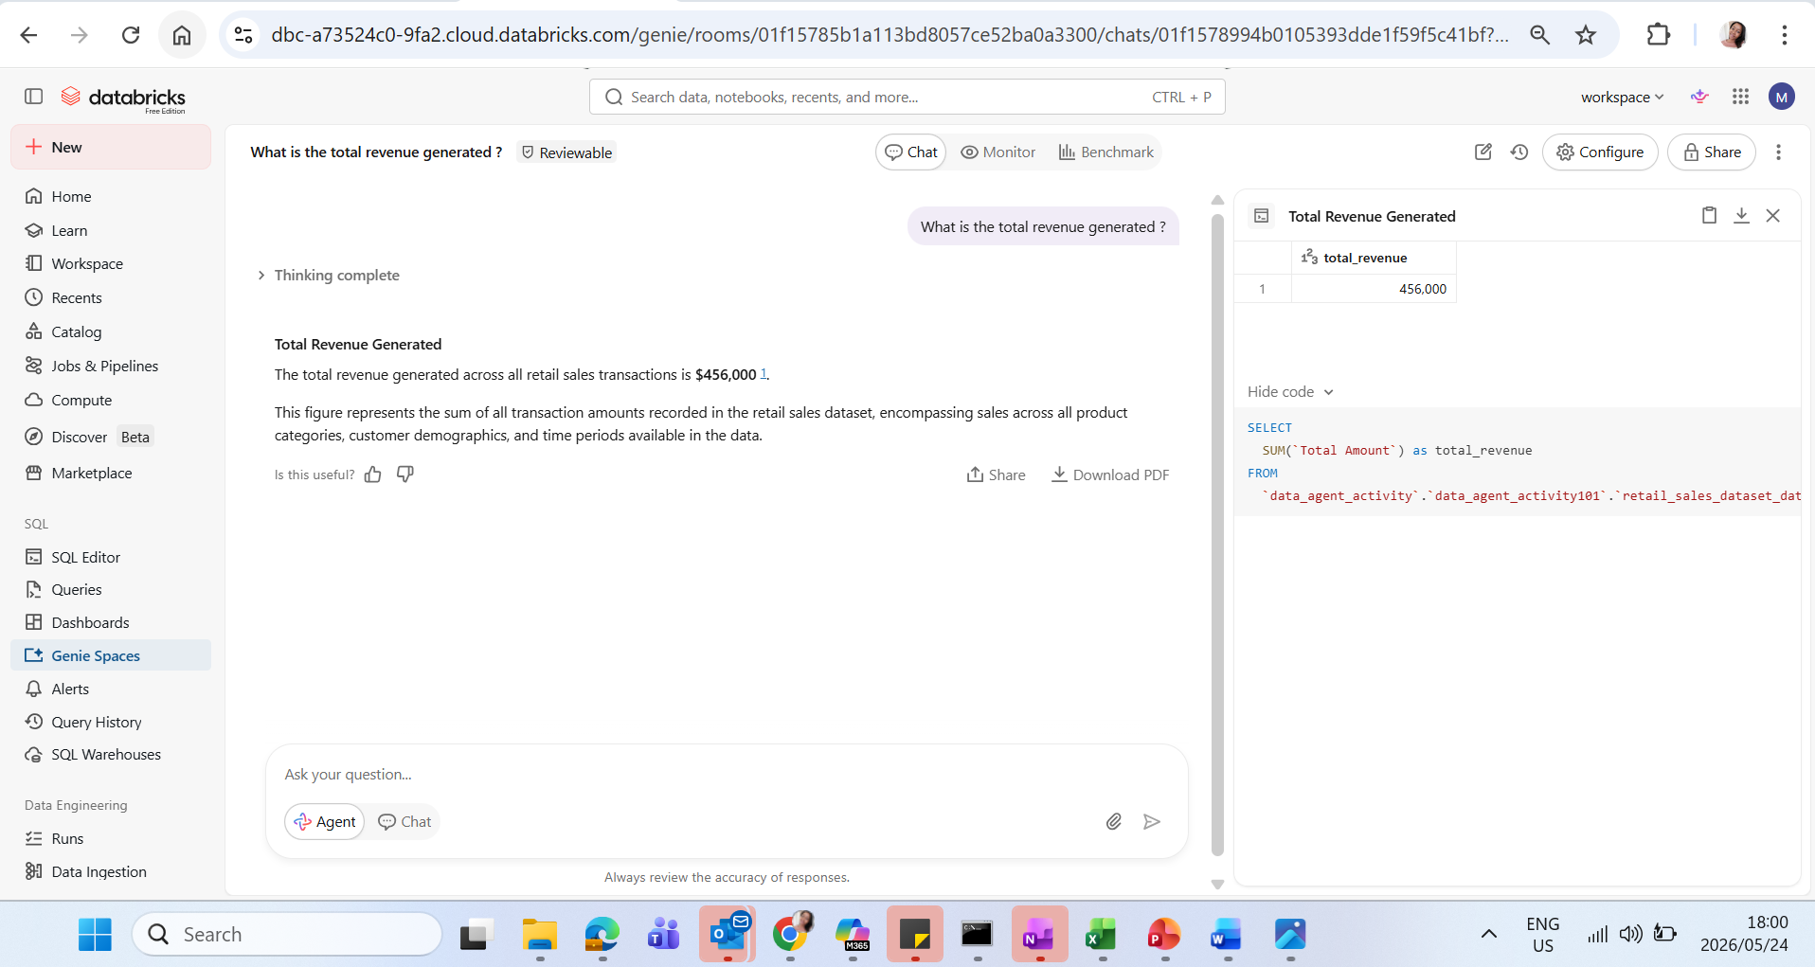
Question 3.
Which product category is most popular by quantity sold?
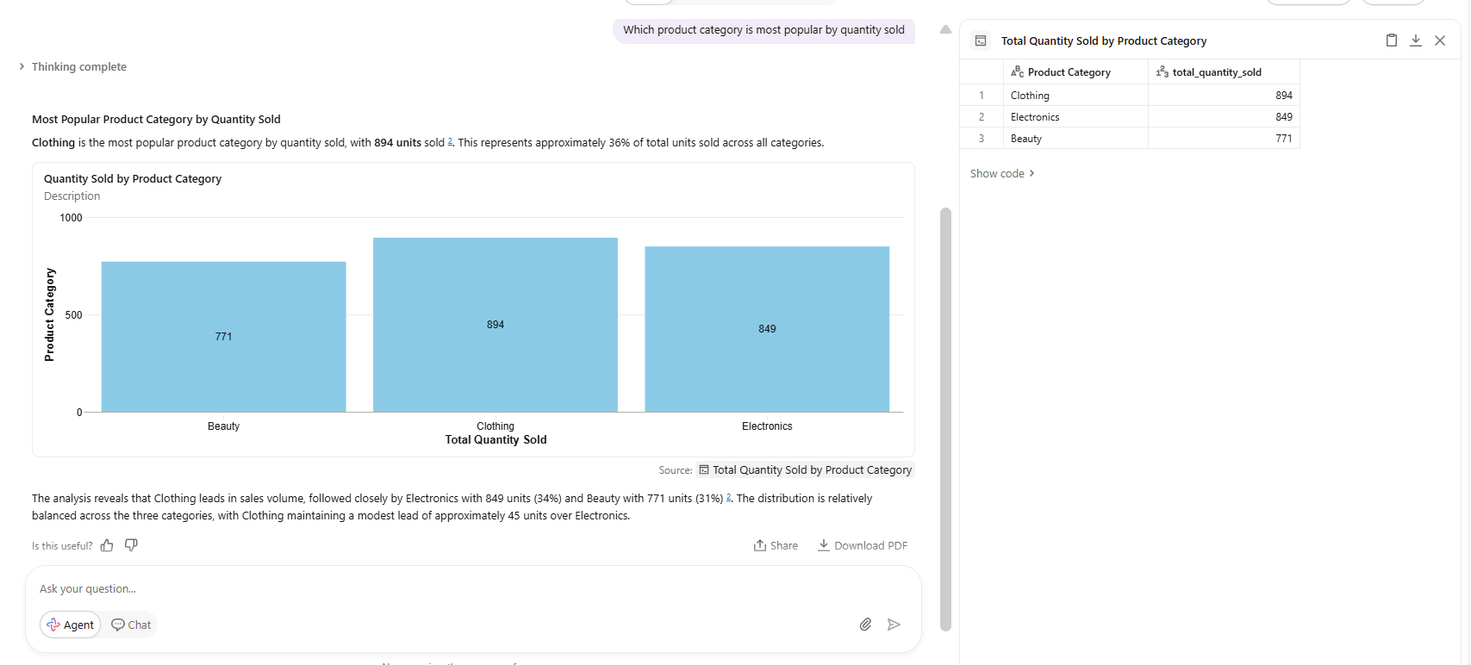
Question 4: Visualize the gender split using a pie chart?
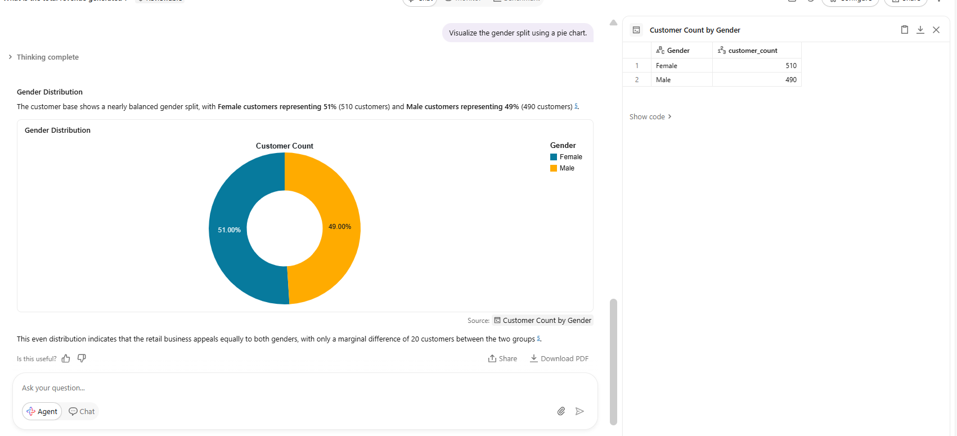

Question 5: Segment customers by spending level (low, medium, high).
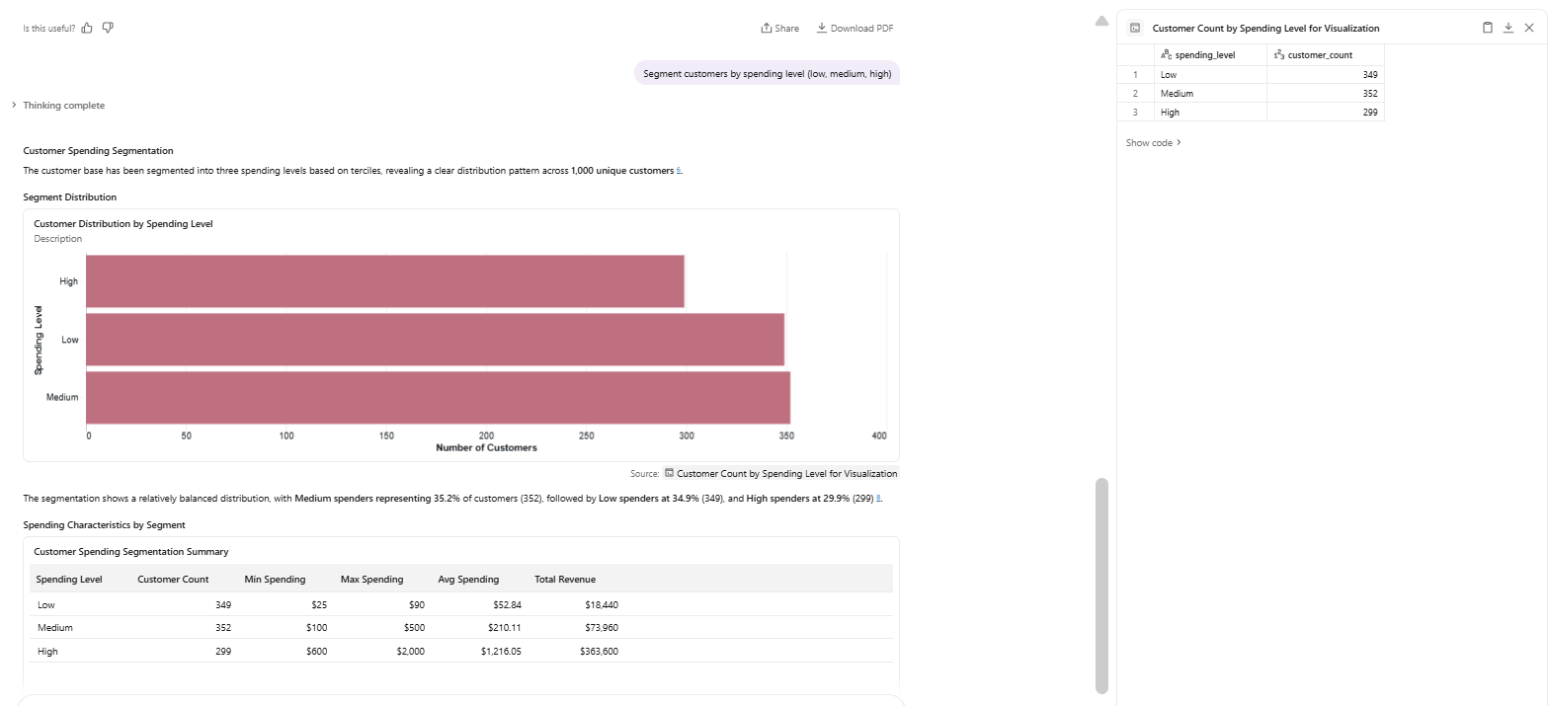
Question 6: Are there any seasonal trends in product category sales?
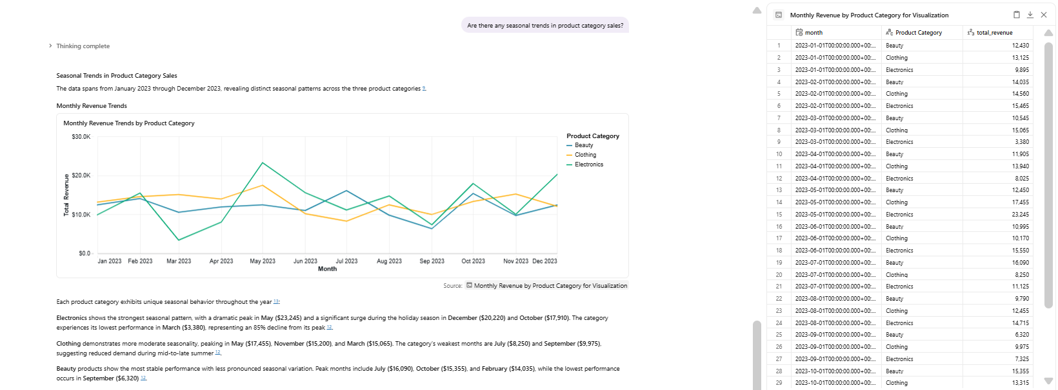
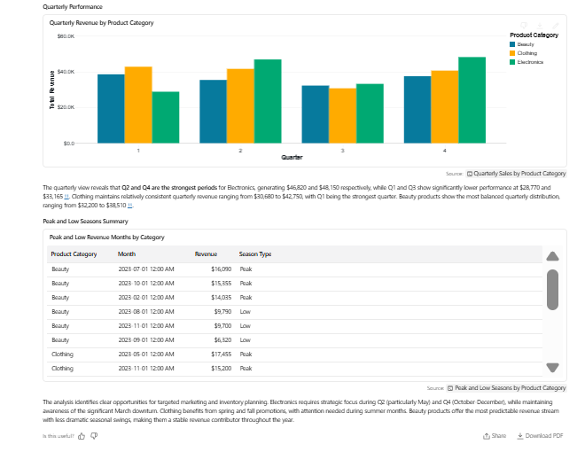
SQL: SELECT
DATE_TRUNC('month', `Date`) as month,
`Product Category`,
SUM(`Total Amount`) as total_revenue
FROM
`data_agent_activity`.`data_agent_activity101`.`retail_sales_dataset_data_agent`
WHERE
`Date` IS NOT NULL
AND `Product Category` IS NOT NULL
AND `Date` < '2024-01-01'
GROUP BY
DATE_TRUNC('month', `Date`),
`Product Category`
ORDER BY
month,
`Product Category`

Question 7: What does each gender buy the most?
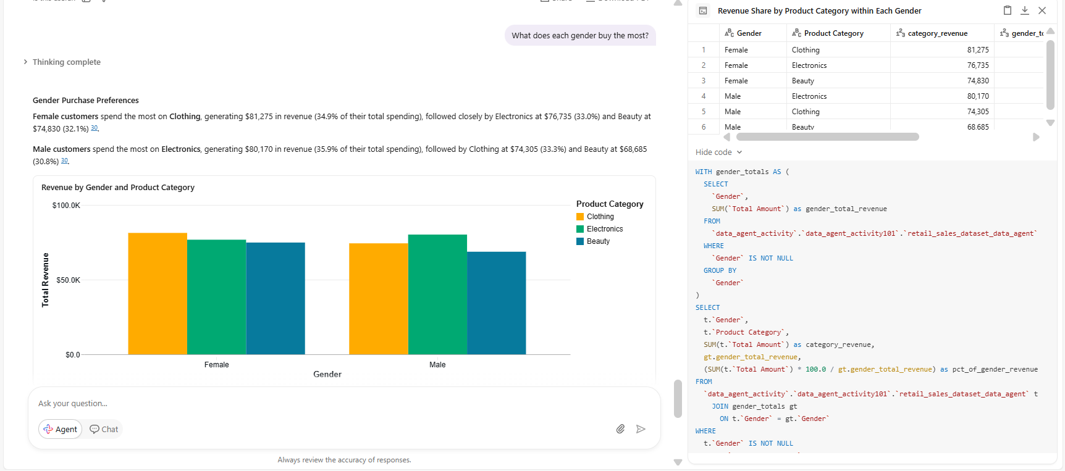

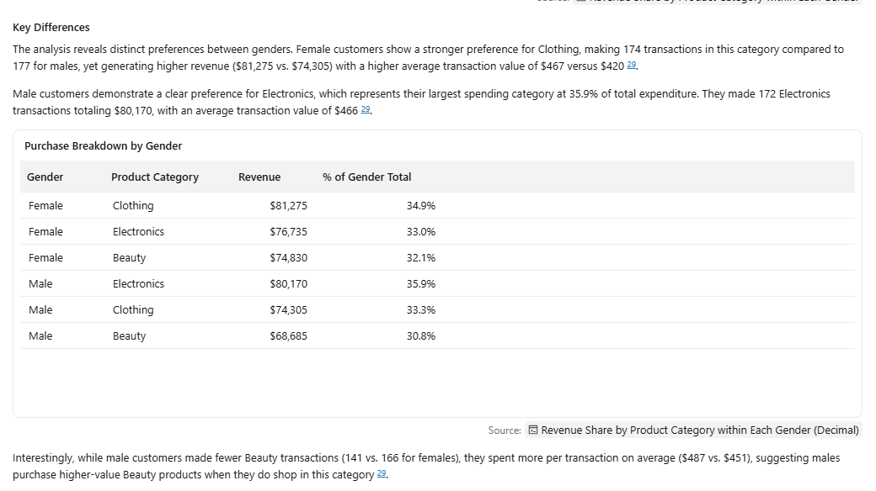

Question 8: Generate a monthly sales summary report
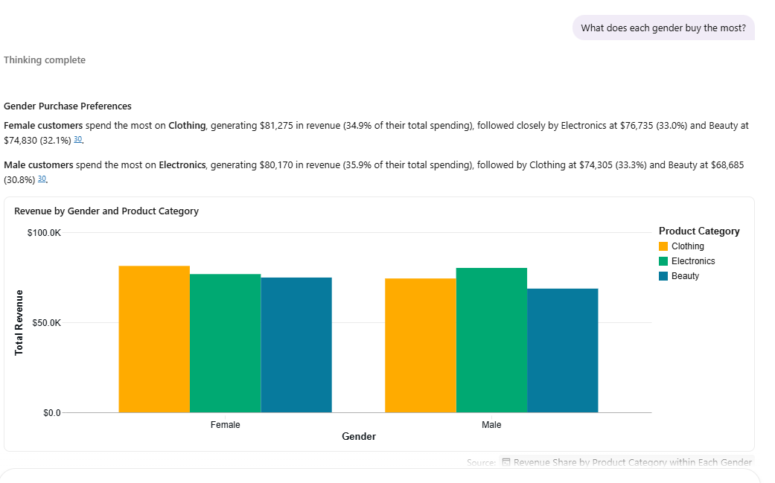
Gender | Product Category | category_revenue | gender_total_revenue | pct_of_gender_revenue
Female | Clothing | 81275 | 232840 | 34.90
Female | Electronics | 76735 | 232840 | 32.95
Female | Beauty | 74830 | 232840 | 32.13
Male | Electronics | 80170 | 223160 | 35.92
Male | Clothing | 74305 | 223160 | 33.29
Male | Beauty | 68685 | 223160 | 30.77
SQL: WITH gender_totals AS (
SELECT
`Gender`,
SUM(`Total Amount`) as gender_total_revenue
FROM
`data_agent_activity`.`data_agent_activity101`.`retail_sales_dataset_data_agent`
WHERE
`Gender` IS NOT NULL
GROUP BY
`Gender`)
SELECT
t.`Gender`,
t.`Product Category`,
SUM(t.`Total Amount`) as category_revenue,
gt.gender_total_revenue,
(SUM(t.`Total Amount`) * 100.0 / gt.gender_total_revenue) as pct_of_gender_revenue
FROM
`data_agent_activity`.`data_agent_activity101`.`retail_sales_dataset_data_agent` t
JOIN gender_totals gt
ON t.`Gender` = gt.`Gender`
WHERE
t.`Gender` IS NOT NULL
AND t.`Product Category` IS NOT NULL
GROUP BY
t.`Gender`,
t.`Product Category`,
gt.gender_total_revenue
ORDER BY
t.`Gender`,
category_revenue DESC;
Question 9: Which month recorded the highest number of sales? Visualize it

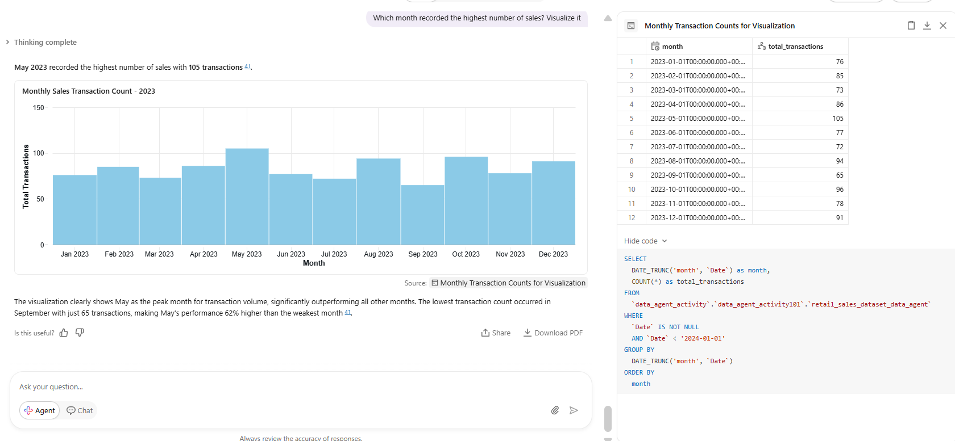
Question 10: How many women bought products in January?
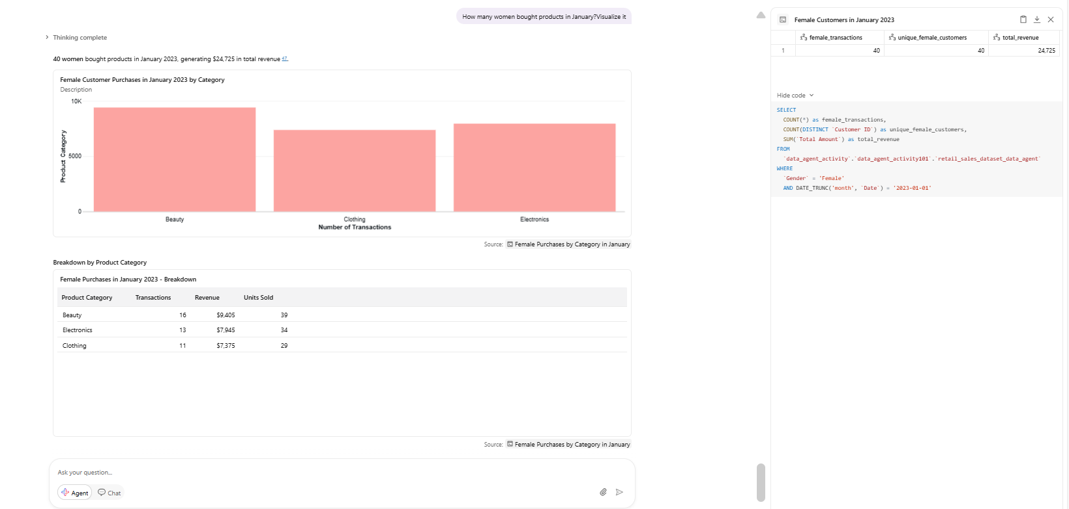

Step 7: Validate the Answers
- Identify the customer profile most likely to make a high-value purchase.
--Identify the customer profile most likely to make a high-value purchase--

WITH high_value_threshold AS (
SELECT
PERCENTILE_CONT(0.80)
WITHIN GROUP(ORDER BY`Total Amount`) as threshold
FROM
`data_agent_activity`.`data_agent_activity101`.`retail_sales_dataset_data_agent`
WHERE
`Total Amount` IS NOT NULL),
all_transactions AS (
SELECT
`Product Category`,
COUNT(*) as total_trans
FROM
`data_agent_activity`.`data_agent_activity101`.`retail_sales_dataset_data_agent`
WHERE
`Product Category` IS NOT NULL
GROUP BY
`Product Category`),
high_value_trans AS (
SELECT
t.`Product Category`,
COUNT(*) as high_value_trans
FROM
`data_agent_activity`.`data_agent_activity101`.`retail_sales_dataset_data_agent` t
CROSS JOIN high_value_threshold h
WHERE
t.`Total Amount` >= h.threshold
AND t.`Product Category` IS NOT NULL
GROUP BY
t.`Product Category`
)
SELECT
a.`Product Category`,
(h.high_value_trans * 100.0 / a.total_trans) as high_value_rate
FROM
all_transactions a
JOIN high_value_trans h
ON a.`Product Category` = h.`Product Category`
ORDER BY
high_value_rate DESC;

Product Category | high_value_rate
Beauty | 22.14
Electronics | 20.46
Clothing | 18.23

- Visualize the gender split using a pie chart
SELECT
`Gender`,
COUNT(*) as customer_count
FROM
`data_agent_activity`.`data_agent_activity101`.`retail_sales_dataset_data_agent`
WHERE
`Gender` IS NOT NULL
GROUP BY
`Gender`
ORDER BY
customer_count DESC;
Gender | customer_count
Female | 510
Male | 490

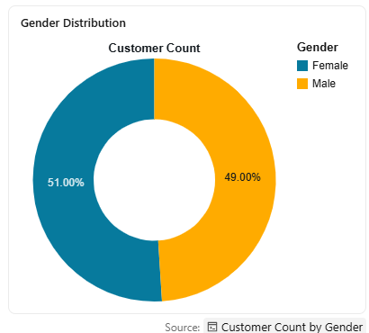
- Which product category is most popular by quantity sold
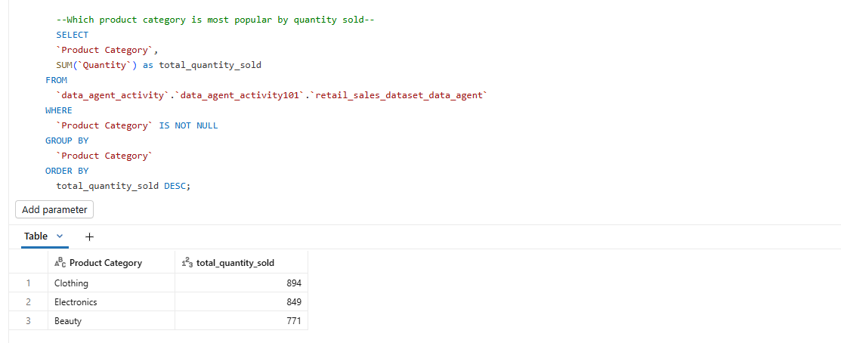

Step 8: The Write-Up Document

Top 5 Insights from the Retail Sales Dataset
• High-value customers drive the majority of revenue: Just 20% of transactions (202 out of 1,000) account for 63% of total revenue ($286,800 out of $456,000), with these high-value purchases averaging $1,420 compared to $212 for regular transactions. This concentration indicates significant opportunity in targeting and retaining premium customers.
• Younger customers show the highest propensity for premium purchases: The 18-24 age group demonstrates a 26.8% high-value purchase rate, significantly outperforming all other age segments. This challenges traditional assumptions about purchasing power and suggests younger demographics represent a critical growth segment for premium product strategies.
• Product categories are remarkably balanced despite different seasonal patterns: Electronics, Clothing, and Beauty each contribute approximately one-third of total revenue (34.4%, 34.1%, and 31.5% respectively). However, Electronics exhibits the highest volatility with dramatic seasonal swings, while Beauty maintains the most stable performance throughout the year.
• May represents a critical revenue peak across all metrics: May 2023 achieved the highest revenue ($53,150), most transactions (105), and greatest units sold (259), driven primarily by a 57% month-over-month surge in Electronics sales 42,46. This peak suggests strong seasonal demand patterns that can be leveraged for strategic planning.
• Each customer makes exactly one purchase, indicating acquisition-focused business model: The dataset shows 1,000 transactions from 1,000 unique customers, with no repeat purchases. This pattern suggests either a new customer acquisition focus or a snapshot of first-time buyers, highlighting a significant opportunity to develop retention and loyalty strategies to drive repeat business.

Recommendations:
- Increase average basket: Size Some customers purchase low quantities despite moderate transaction frequency. Recommendation Add “Frequently Bought Together” suggestions. Introduce discounts for multi-item purchases. Create bundle offers across categories.
- Target female customers more deliberately: With a slight female majority (51%), and likely higher Beauty & Clothing engagement, tailored marketing campaigns, personalised emails, or loyalty programmes aimed at female shoppers could meaningfully increase revenue.
- Reduce One-Item transactions: The average quantity per transaction is 2.5, but many customers buy just 1 item. Offering "add one more for a discount" or free shipping thresholds above a minimum basket value could push average quantity and order value higher.

Conclusion
Overall, the Retail Sales Insights Agent performed well as a data analysis tool. Setting up the agent in Databricks was straightforward and once connected to the retail_sales_data_set101.retail_data_set_exc101.retail_sales_dataset_activity_101 dataset, it responded accurately and efficiently to a wide range of business questions. The agent was particularly effective at summarising sales trends, comparing product categories, and generating customer insights — tasks that would otherwise require manual analysis.
The most challenging aspect was crafting precise agent instructions. Vague prompts occasionally produced generic responses, which required refinement to get more specific, data-driven answers. Validating the agent's outputs against the raw data was also time-consuming but necessary to confirm reliability.
If given the opportunity to redo this project, the agent instructions would be made more structured from the outset — specifying the column names, expected output format, and the type of insights required. Additionally, a larger or more detailed dataset with transaction timestamps and customer demographics would allow the agent to uncover deeper patterns.
Despite these challenges, the Retail Sales Insights Agent proved to be a valuable tool for turning raw retail data into actionable business intelligence.

GitHub Repository
All project files, including the dataset, agent configuration notes, and this write-up document, are available at the following GitHub repository: https://github.com/mpsejake-maker/Building_a_Retail_Sales_Data_Agent_on_Databricks-_RetailSales-Insights/upload/main

